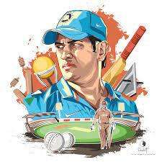

SCHOOL OF DATA SCIENCE AND FORECASTING

.

BEST 11 PLAYERS BASED ON ( ICC Men's T20 World Cup)

REPORT

*In partial fulfillment of the award of the degree*

*of*

MASTER OF TECHNOLOGY

In

DATA SCIENCE

*Submitted by Submitted to*

DIKSHANT NARWARE (DS7A-2206) Prof. MOHIT KUMAR

MUSKAN TIROLE (DS7A-2210) Designation: Lecturer

DEEPAK KUMAR (DS7A-2205)

HIMANI SARATHE (DS7A-2206)

HIMANSHU SURYAVANSHI ( DS7A-2209)

ATHARVA HAJARNIS (DS7B-2207)

DEVI AHILYA VISHWAVIDALAYA

Indore (M.P.)

JAN, 2023

SCHOOL OF DATA SCIENCE AND FORECASTING DEVI AHILYA VISHWAVIDYALAYA

INDORE (M.P)

STATEMENT OF ORIGINALITY

Following the requirements for the Degree of Master of Technology in DATA SCIENCE in the SCHOOL OF DATA SCIENCE AND FORECASTING, I present This report is completed under the Supervision of:

Prof. Mohit Kumar

Designation: Lecturer

I declare that the work presented in the report is my work except as acknowledged in the text and footnotes, and that to my knowledge this material has not been submitted either in whole or in part, for any other degree at this University or any other such Institution.

Name of the Students:

Dikshant Narware

Muskan Tirole

Deepak Kumar

Himanshu Suryavanshi

Atharva Hajarnis

Himani Sarathe

Date: 09/01/2023

# ACKNOWLEDGEMENT

### We would like to express our gratitude to the **Prof. Mohit Kumar** Faculty of the **SCHOOL OF DATA SCIENCE AND FORECASTING** Department for guidance and support throughout this work. She has been a constant source of inspiration to us throughout this work. We consider ourselves extremely fortunate for having had the opportunity to learn and work under her guidance over the entire period. I also express my sincere thanks to all the teachers of the **SCHOOL OF DATA SCIENCE AND FORECASTING**, who gave me the golden opportunity to do this wonderful Report on the topic “**BEST 11 PLAYERS BASED ON ( ICC Men's T20 World Cup)**”, which also helped me in doing a lot of research and I came to know about so many new things I am thankful to them. Last but not least I would like to thank all my friends and family members who were involved directly or indirectly in my work.

( Dikshant Narware , Muskan Tirole , Himanshu Suryavanshi , Deepak Kumar, Himani Sarathe , Atharva Hajarnis )

##### PROBLEM STATEMENT :-

### **This project is based on Analysis to find the best 11 players based on T20 ( Cricket World cup ) Data.**



###### Player Analysis :

In cricket the performance of the players whether bowler or batsman is being analyzed with the help of very simple statistical tools. Mostly average scores, strike rate, average runs per wicket are being used.

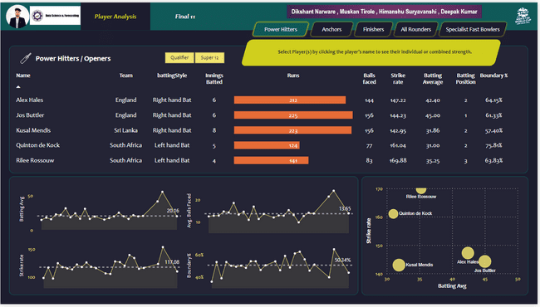

###### Top Order Battesman:

The top order is defined as the batters batting at positions 1, 2, and 3. The batters who bat at positions 3, 4 and 5 in the order are sometimes the most technically proficient batters with the best stroke play

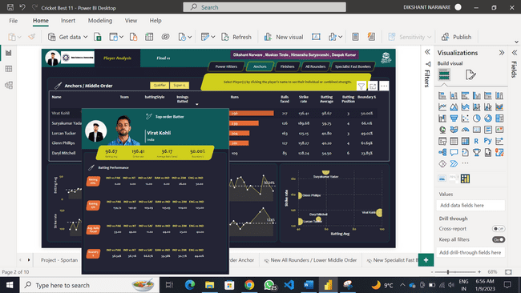

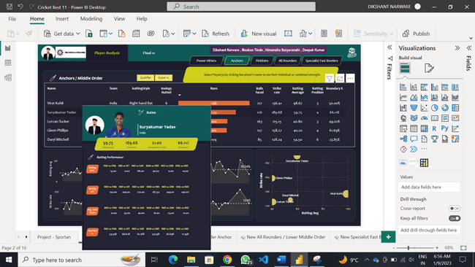

###### All Rounder Batsman:

Based on an analysis of runs scored, balls bowled and wickets taken by batting position, it was suggested in a 2022 article that to be considered a genuine all-rounder, a player should average at least 49.3 runs and take at least two wickets per game – a record achieved by only 13 players in the history of test match

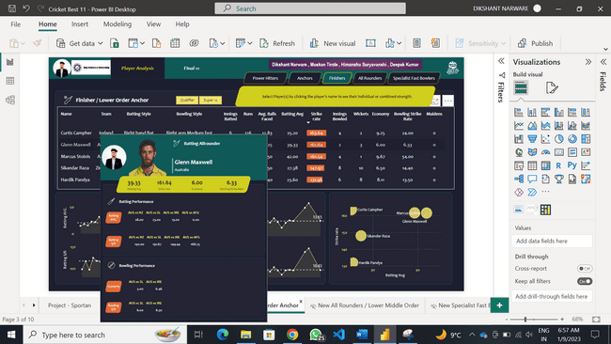

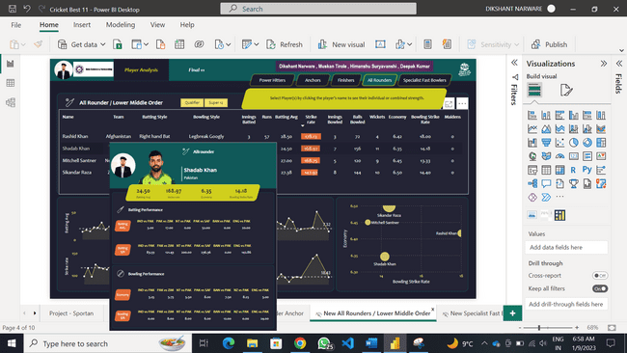

###### Bowling Peformance:

A cricketer's bowling average is calculated by dividing the numbers of runs they have conceded by the number of wickets they have taken.

In fact, your approach and bowling swing are the two MOST important skills that you need to work on to improve your overall bowling skills and raise your bowling average.

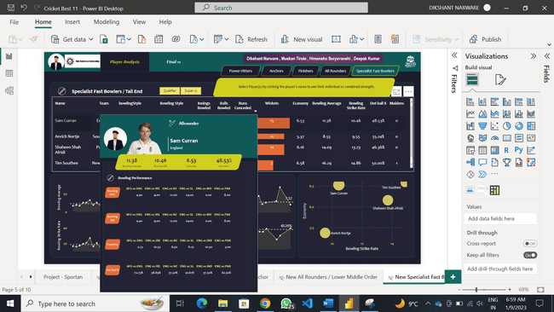

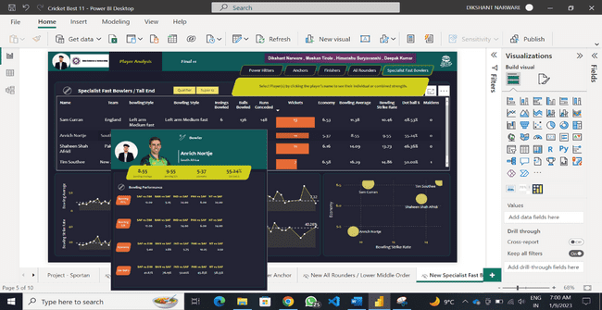

###### Final 11 Players Selected :

Each cricket board appoints a committee of selectors generally comprising of veteran cricketers. The selectors use their experience and expertise to select the team based on recent performance of the available cricketers.  
 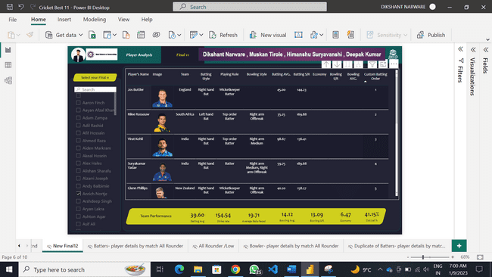

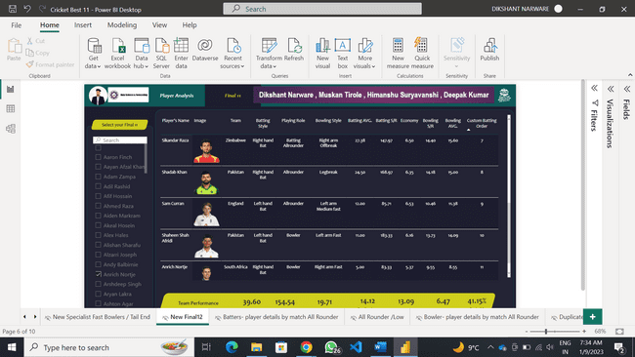

###### Batsman Dashboard:

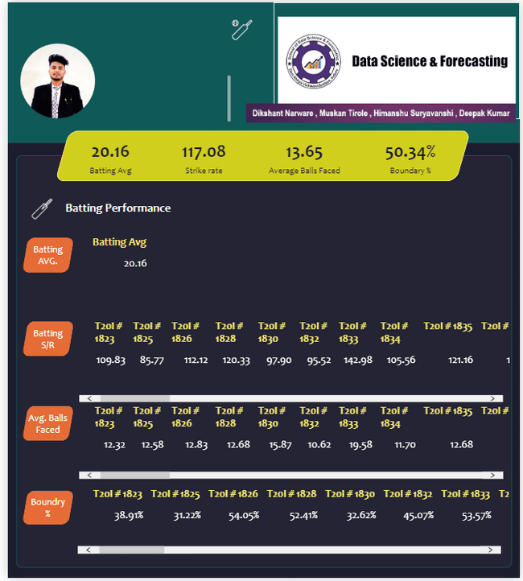

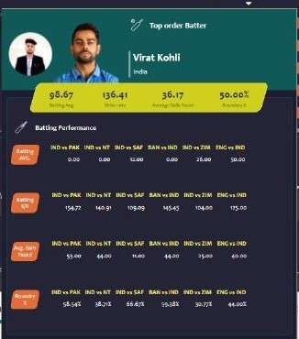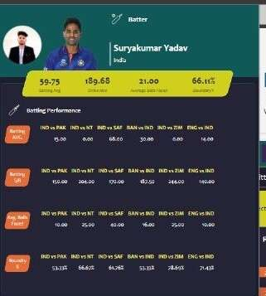

###### Bowlers Dashboard:

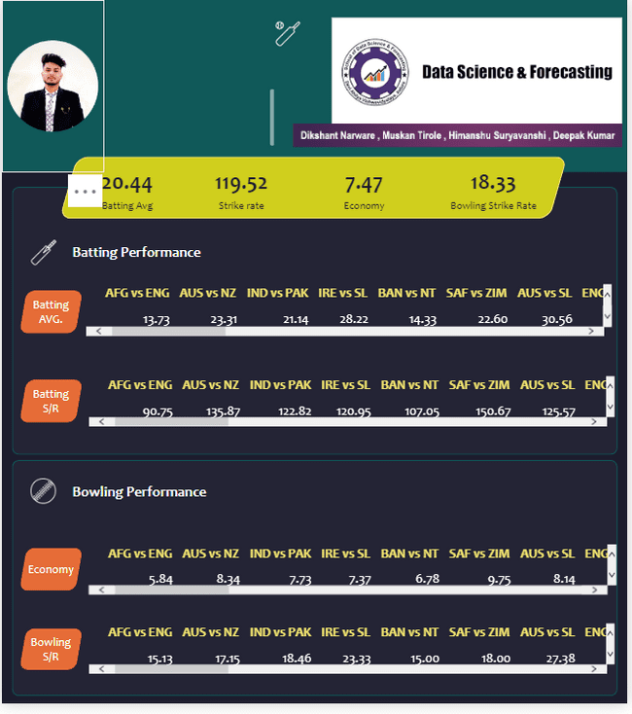

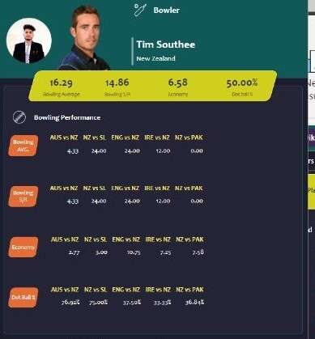

###### DATASET (BEST 11 PLAYERS BASED ON ICC Men's T20 World Cup):-

Match Details Summary:

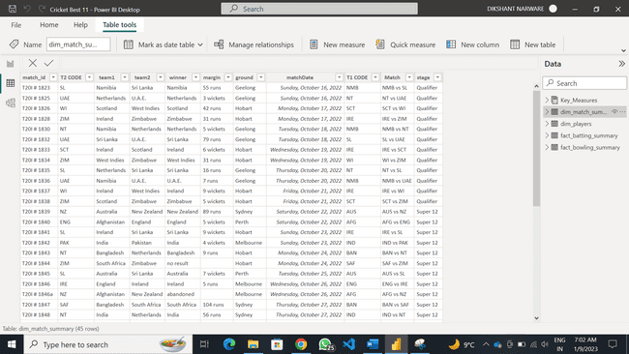

Players Details List:

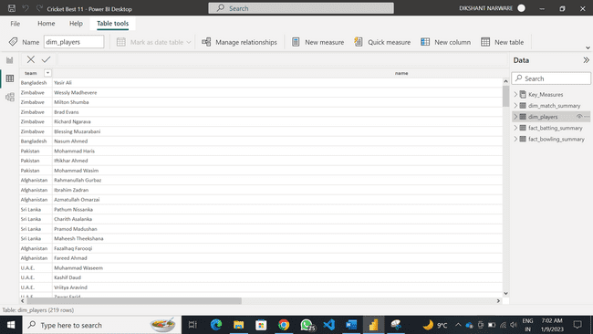

Batting Details Summary:

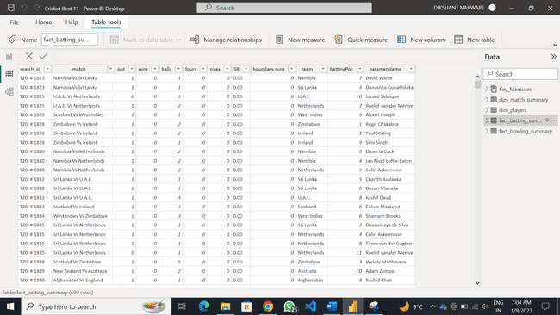

Bowling Summary:

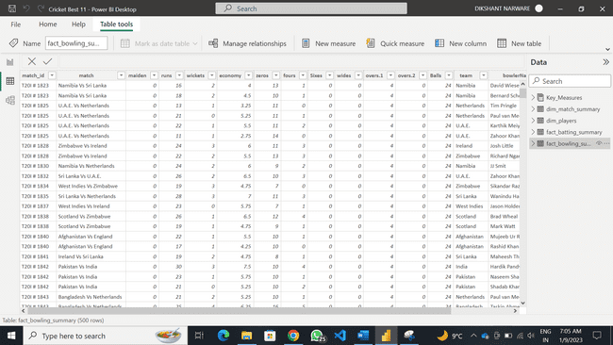

###### Data Modeling:

Data warehouse modeling is the process of designing the schemas of the detailed and summarized information of the data warehouse. The goal of data warehouse modeling is to develop a schema describing the reality, or at least a part of the fact, which the data warehouse is needed to support.

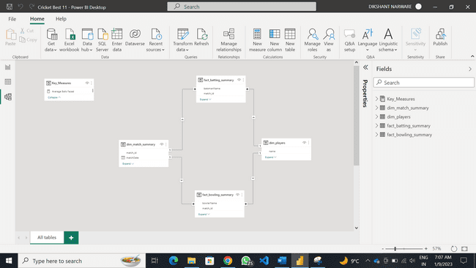



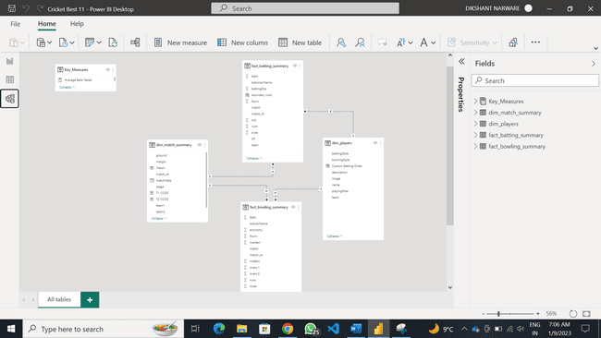

###### Conclusion:

It is easily one of the most prevalent sports in the world. This game consists of two teams that include 11 players each. The main aim of the game is to score the highest number of runs. It is played on a pitch in a field that is well-maintained for the same purpose.

Cricket is a team sport involving a bat and ball played between two teams of eleven players each. The objective is to score more runs (points) than the opposing team. A match is divided into innings during which one team bats, two batter at a time, and the other team bowl.

# Reference:-

*Project Source:* <https://drive.google.com/file/d/1NB7kkoRLrgvxbZQGIaRKd461Sf6fOZS_/view?usp=sharing>

*Kaggle* : <https://www.kaggle.com/datasets/rajsengo/icc-mens-t20-world-cup>

*Power Bi* : <https://powerbi.microsoft.com/en-us/desktop/>

*MySQL* : <https://www.mysql.com/products/community/>

*ETL Talend Open Studio* : <https://www.talend.com/resources/get-started-talend-open-studio-data-integration/>

Website:-

Dikshant Narware : <http://dikshantnarware.liveblog365.com/>